Type of Manuscript:
Research

Twenty-Eight-Day Subacute Toxicity of Ethanolic Morus alba Leaf Extract in Wistar Rats
Mirnawati Salampe¹*, Sukamto S. Mamada², Imrawati³, Akbar Awaluddin¹, Ariansyah¹, Putri Amanda Dewi⁴, Agustina Putri Landa⁴, Anggi Nurdiniawati Saputri⁴, Inggrid Yolendari⁴, Dewiyanti Rumengan⁴
¹ Department of Pharmacology and Clinical Pharmacy, Faculty of Health Sciences, Almarisah Madani University, Makassar, Indonesia
² Department of Pharmacy, Faculty of Pharmacy, Hasanuddin University, Makassar, Indonesia
³ Department of Pharmaceutical Chemistry, Faculty of Health Sciences, Almarisah Madani University, Makassar, Indonesia
⁴ Faculty of Health Sciences, Almarisah Madani University, Makassar, Indonesia

Corresponding author: Mirnawati Salampe, Department of Pharmacology and Clinical Pharmacy, Faculty of Health Sciences, Almarisah Madani University, Makassar 90245, Indonesia. Phone: +62 852 4243 7072; E-mail: mirnachamto@gmail.com

ABSTRACT
Background: Repeated-dose safety data for ethanolic Morus alba leaf preparations remain limited, although Morus alba has been widely investigated as a traditional medicinal plant with potential metabolic benefits. This study evaluated the 28-day oral toxicity of ethanolic M. alba leaf extract in adult Wistar rats.
Methods: Thirty rats (five females and five males per group) were allocated to a normal control group or extract-treated groups receiving 200 or 400 mg/kg body weight once daily for 28 consecutive days. Body weight, hematological indices, serum creatinine, urea, aspartate aminotransferase, alanine aminotransferase, and liver and kidney histopathology were assessed.
Results: No mortality or overt clinical signs of toxicity were observed, and body weight increased overall in all groups. Most hematological and serum biochemical parameters were comparable with control values, although selected erythrocyte-related indices and creatinine differed in female rats. Liver sections showed mild hydropic or cellular degeneration at 200 mg/kg and moderate fatty degeneration, hepatocellular necrosis, and inflammatory cell infiltration at 400 mg/kg. Kidney histology remained preserved at 200 mg/kg, whereas mild renal edema was observed at 400 mg/kg.
Conclusions: The ethanolic extract was generally tolerated at the tested doses; however, histopathological findings at 400 mg/kg suggest potential dose-related liver and kidney effects. Studies with extract standardization, organ-weight assessment, and quantitative histopathology are needed before therapeutic development.

KEYWORDS: Ethanolic extract, histopathology, Morus alba, subacute toxicity, Wistar rats

INTRODUCTION
Metabolic syndrome (MetS) is characterized by central obesity, insulin resistance, dyslipidemia, and impaired glucose regulation, and it increases the risk of cardiovascular disease and type 2 diabetes mellitus¹. Poor long-term adherence to pharmacological and lifestyle interventions remains a challenge in chronic metabolic disorders, encouraging the exploration of complementary agents with multiple metabolic targets and acceptable safety profiles².
Medicinal plants contain diverse bioactive compounds that may act on mechanisms involved in MetS, including insulin signaling, lipid and glucose metabolism, oxidative stress, and low-grade inflammation^{3,4}. Morus alba L. has long been used in Asian traditional medicine and contains flavonoids, alkaloids, phenolic acids, and related constituents with hypoglycemic, antioxidant, anti-inflammatory, anti-obesity, cardiometabolic, and pancreatic beta-cell protective properties⁵⁻¹⁰. These findings support further investigation of M. alba leaf preparations as complementary candidates for metabolic disorders.
Before plant preparations can be advanced for therapeutic use, their repeated-dose safety should be characterized. Acute studies of M. alba preparations have reported no mortality or major toxic signs after high-dose exposure, and a 28-day study of an aqueous extract reported no relevant toxicity at doses up to 4,000 mg/kg/day¹¹⁻¹³. These data cannot be directly generalized to ethanolic extracts because extraction solvent can influence phytochemical composition, extraction yield, and biological activity^{14,15}.
Twenty-eight-day repeated-dose oral studies provide preliminary information on potential target-organ effects during sustained exposure¹⁶. Hematological indices, serum biochemical markers, and histopathological assessment are relevant for plant-derived preparations because the liver and kidneys are central to xenobiotic metabolism and elimination. This study evaluated the 28-day oral toxicity of ethanolic M. alba leaf extract in male and female Wistar rats by assessing body weight, hematological profiles, liver and kidney function markers, and liver and kidney histopathology.
METHODS AND MATERIALS
Plant material and extraction
Morus alba leaves were collected in Indonesia. Dried powdered leaves were extracted by maceration with 70% ethanol following a previously described natural-product extraction approach¹⁷. The powdered material was moistened and soaked in solvent in a dark place at room temperature for 72 h with occasional stirring. After filtration, the residue was remacerated with the same solvent. The combined filtrates were concentrated using a rotary evaporator at 60 °C and 75 rpm to obtain a thick extract. The extract was frozen at -20 °C for approximately 24 h and subsequently lyophilized for 24 h to produce a dry extract. Freeze-drying was used to support extract stability and preservation of bioactive constituents¹⁸.
Animals and ethical approval
Thirty adult Wistar rats of both sexes (2-3 months old; 150-180 g) were obtained from a university animal facility. During one week of acclimatization, the animals were maintained under standard laboratory conditions with a 12-h light/dark cycle and free access to food and water. Only animals that maintained or gained body weight during acclimatization were included. The animal study protocol was approved by an institutional research ethics committee (Approval No. 12.199/KOMETIK/STIFA/XII/2025).
Subacute toxicity study
The oral toxicity study was conducted for 28 consecutive days. After weighing, animals were allocated to three groups, each comprising 10 rats (five females and five males). Group I served as the normal control group, whereas Groups II and III received ethanolic M. alba leaf extract (EEM) at 200 and 400 mg/kg body weight, respectively. The extract was administered orally once daily. Animals were observed for mortality and overt clinical signs of toxicity during treatment, and body weight was recorded weekly. At the end of treatment, blood samples were collected via orbital venous sinus and cardiac puncture for hematological and biochemical analyses. The animals were then euthanized, and liver and kidney tissues were collected for histopathological examination.
Hematological analysis
Hematological parameters included erythrocyte count, red blood cell indices, total and differential white blood cell counts, and platelet indices. Measurements were performed using an automated hematology analyzer (Dymind DH36; Dymind Biotechnology, Shenzhen, China).
Biochemical analysis
Serum creatinine and urea were measured as kidney-function indicators, while aspartate aminotransferase (AST) and alanine aminotransferase (ALT) were measured as liver-function indicators. Analyses were conducted using a Humalyzer 4000 analyzer (HUMAN Diagnostics, Wiesbaden, Germany) with HUMAN diagnostic kits.
Histopathological analysis
Liver and kidney tissues were fixed in formalin and processed using standard histological procedures. Briefly, tissues were dehydrated through graded alcohol solutions, embedded in paraffin, sectioned at 5 µm, stained with hematoxylin and eosin (H&E), and examined under a light microscope for histopathological alterations.
Statistical analysis
Body-weight, hematological, and biochemical data are presented as mean ± standard deviation (SD). Female and male results were reported separately. Differences among groups were analyzed using one-way analysis of variance followed by the least significant difference post hoc test in SPSS version 24. Statistical significance was set at P < 0.05.
RESULT
Clinical observations and body-weight changes
No mortality or overt signs of toxicity were observed in either sex during the 28-day administration of EEM. All groups showed an overall increase in body weight during treatment (Figure 1). Among female rats, the normal control, EEM 200 mg/kg, and EEM 400 mg/kg groups showed increases of 23.5%, 7.6%, and 12.5%, respectively. Among male rats, the normal control and EEM 400 mg/kg groups showed increases of approximately 38% and 30%, respectively, whereas the EEM 200 mg/kg group showed an increase of approximately 10%.

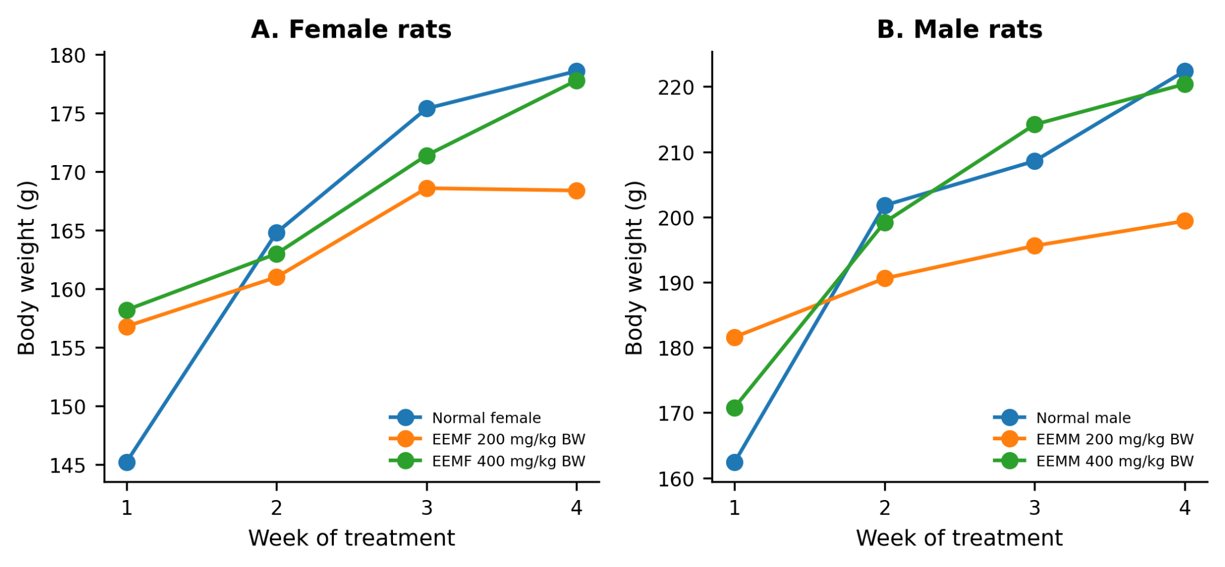
Figure 1. Body-weight changes in female and male Wistar rats during 28 days of oral administration of ethanolic Morus alba leaf extract. EEM, ethanolic extract of Morus alba leaves.
Hematological findings
In female rats, leukocyte and platelet parameters were generally comparable between treated groups, whereas selected erythrocyte-related indices differed significantly among groups (Table 1). In male rats, erythrocyte, leukocyte, and platelet parameters were comparable across the normal control and EEM-treated groups (Table 2).
Table 1. Hematological parameters in female rats after 28 days of treatment.
Parameter | Normal control | EEM 200 mg/kg BW | EEM 400 mg/kg BW
Erythrocytes (10^6/µL) | 6.75 ± 0.31 | 7.32 ± 0.40 | 7.37 ± 0.54
Hemoglobin (g/dL) | 16.32 ± 0.90 (a) | 17.80 ± 0.82 (b) | 17.06 ± 0.61 (a,b)
Hematocrit (%) | 41.08 ± 1.14 (a) | 44.58 ± 1.93 (b) | 44.34 ± 2.49 (b)
MCV (fL) | 60.88 ± 1.54 | 60.92 ± 1.42 | 60.20 ± 2.17
MCH (pg) | 24.18 ± 0.49 | 24.32 ± 1.45 | 23.24 ± 1.28
MCHC (g/dL) | 39.72 ± 1.39 | 39.94 ± 1.87 | 38.52 ± 1.03
RDW-CV (%) | 17.08 ± 1.31 | 15.00 ± 1.27 | 15.82 ± 1.04
RDW-SD (fL) | 35.06 ± 2.60 (a) | 30.80 ± 2.14 (b) | 31.94 ± 2.35 (a,b)
Mentzer index | 9.04 ± 0.62 | 8.35 ± 0.62 | 8.21 ± 0.83
RDWI | 154.51 ± 14.58 (a) | 125.17 ± 11.76 (b) | 130.21 ± 16.51 (b)
WBC (10^3/µL) | 21.52 ± 3.17 (a) | 14.54 ± 2.15 (b) | 15.13 ± 5.90 (b)
Lym (%) | 94.76 ± 1.67 | 93.96 ± 4.25 | 92.88 ± 2.54
Gran (%) | 1.14 ± 0.42 | 1.56 ± 1.28 | 1.72 ± 0.80
Mid (%) | 4.10 ± 1.40 | 4.48 ± 2.97 | 5.40 ± 1.75
Lym (10^9/L) | 20.38 ± 2.85 | 13.63 ± 1.95 | 14.02 ± 5.32
Gran (10^9/L) | 0.25 ± 0.10 | 0.24 ± 0.21 | 0.27 ± 0.19
Mid (10^9/L) | 0.90 ± 0.37 | 0.67 ± 0.48 | 0.84 ± 0.47
PLT (10^3/µL) | 1260.20 ± 245.70 | 1123.60 ± 112.93 | 1065.60 ± 99.80
MPV (fL) | 7.32 ± 0.33 | 7.58 ± 0.52 | 7.34 ± 0.39
PDW (%) | 7.84 ± 0.39 | 7.66 ± 0.97 | 8.10 ± 0.45
PCT (%) | 0.93 ± 0.20 | 0.85 ± 0.12 | 0.78 ± 0.08
P-LCR (%) | 12.32 ± 2.58 | 15.02 ± 3.78 | 11.92 ± 2.44
P-LCC (10^3/µL) | 158.20 ± 50.92 | 170.40 ± 51.50 | 126.80 ± 30.43
Data are expressed as mean ± SD (n = 5 per group). Different superscript letters indicate significant differences among groups (P < 0.05); identical letters indicate no significant difference. EEM, ethanolic extract of Morus alba leaves.
Table 2. Hematological parameters in male rats after 28 days of treatment.
Parameter | Normal control | EEM 200 mg/kg BW | EEM 400 mg/kg BW
Erythrocytes (10^6/µL) | 7.80 ± 1.17 | 7.81 ± 0.84 | 8.41 ± 0.54
Hemoglobin (g/dL) | 17.34 ± 2.42 | 17.90 ± 1.70 | 18.98 ± 0.61
Hematocrit (%) | 45.62 ± 7.29 | 45.80 ± 4.03 | 49.94 ± 2.49
MCV (fL) | 58.48 ± 1.15 | 58.78 ± 2.03 | 59.40 ± 2.17
MCH (pg) | 22.30 ± 0.39 | 23.00 ± 0.98 | 22.62 ± 1.28
MCHC (g/dL) | 38.14 ± 1.22 | 39.12 ± 0.65 | 38.10 ± 1.03
RDW-CV (%) | 17.68 ± 1.37 | 18.42 ± 1.31 | 17.14 ± 1.04
RDW-SD (fL) | 34.58 ± 2.30 | 36.22 ± 2.34 | 33.96 ± 2.35
Mentzer index | 7.65 ± 1.25 | 7.62 ± 1.16 | 7.12 ± 0.83
RDWI | 134.69 ± 18.81 | 139.49 ± 16.09 | 121.88 ± 16.51
WBC (10^3/µL) | 15.53 ± 4.35 | 18.64 ± 5.12 | 14.94 ± 5.90
Lym (%) | 93.96 ± 3.11 | 89.82 ± 11.47 | 94.34 ± 2.54
Gran (%) | 1.44 ± 0.94 | 3.34 ± 4.65 | 1.58 ± 0.80
Mid (%) | 4.60 ± 2.19 | 6.84 ± 6.86 | 4.08 ± 1.75
Lym (10^9/L) | 14.53 ± 3.91 | 16.33 ± 2.78 | 14.12 ± 5.32
Gran (10^9/L) | 0.24 ± 0.18 | 0.78 ± 1.25 | 0.23 ± 0.19
Mid (10^9/L) | 0.75 ± 0.46 | 1.52 ± 1.88 | 0.59 ± 0.47
PLT (10^3/µL) | 847.20 ± 257.22 | 1030.00 ± 102.41 | 968.00 ± 99.80
MPV (fL) | 7.00 ± 0.23 | 6.98 ± 0.31 | 7.10 ± 0.39
PDW (%) | 7.94 ± 0.44 | 7.44 ± 0.92 | 7.92 ± 0.45
PCT (%) | 0.59 ± 0.18 | 0.72 ± 0.10 | 0.69 ± 0.08
P-LCR (%) | 9.44 ± 1.44 | 10.90 ± 1.81 | 10.70 ± 2.44
P-LCC (10^3/µL) | 79.40 ± 28.07 | 113.20 ± 28.27 | 103.20 ± 30.43
Data are expressed as mean ± SD (n = 5 per group). EEM, ethanolic extract of Morus alba leaves.
Serum biochemical findings
Repeated oral administration of EEM for 28 days did not significantly change urea, AST, or ALT levels compared with the normal control groups in either sex (Tables 3 and 4). Creatinine levels in male rats were comparable across groups. In female rats, creatinine differed significantly between the normal control and EEM 200 mg/kg groups and between the EEM 200 and 400 mg/kg groups.
Table 3. Serum biochemical parameters in female rats after 28 days of treatment.
Parameter | Normal control | EEM 200 mg/kg BW | EEM 400 mg/kg BW
Creatinine (mg/dL) | 1.70 ± 0.26 (a) | 1.15 ± 0.18 (b) | 1.58 ± 0.11 (a)
Urea (mg/dL) | 33.58 ± 3.18 | 47.63 ± 8.70 | 39.24 ± 12.71
AST (U/L) | 225.80 ± 76.42 | 199.20 ± 38.17 | 217.75 ± 7.72
ALT (U/L) | 61.00 ± 13.71 | 47.00 ± 8.34 | 68.20 ± 15.94
Data are expressed as mean ± SD (n = 5 per group). Different superscript letters indicate significant differences among groups (P < 0.05); identical letters indicate no significant difference. AST, aspartate aminotransferase; ALT, alanine aminotransferase; EEM, ethanolic extract of Morus alba leaves.
Table 4. Serum biochemical parameters in male rats after 28 days of treatment.
Parameter | Normal control | EEM 200 mg/kg BW | EEM 400 mg/kg BW
Creatinine (mg/dL) | 1.39 ± 0.45 | 1.40 ± 0.15 | 1.32 ± 0.13
Urea (mg/dL) | 40.06 ± 4.88 | 40.06 ± 11.37 | 44.40 ± 11.66
AST (U/L) | 205.20 ± 9.63 | 264.20 ± 39.44 | 215.60 ± 7.72
ALT (U/L) | 65.00 ± 15.41 | 67.00 ± 14.95 | 62.80 ± 15.94
Data are expressed as mean ± SD (n = 5 per group). AST, aspartate aminotransferase; ALT, alanine aminotransferase; EEM, ethanolic extract of Morus alba leaves.
Histopathological findings
Microscopic examination of liver sections showed mild hydropic or cellular degeneration in male and female rats treated with EEM at 200 mg/kg body weight (Figures 2 and 3). At 400 mg/kg body weight, more pronounced hepatic alterations were observed in both sexes, including moderate fatty degeneration, hepatocellular necrosis, and inflammatory cell infiltration. Kidney histology was preserved in both sexes at 200 mg/kg, with maintained glomerular and tubular structures. Mild renal edema was observed at 400 mg/kg in both sexes (Figure 4).

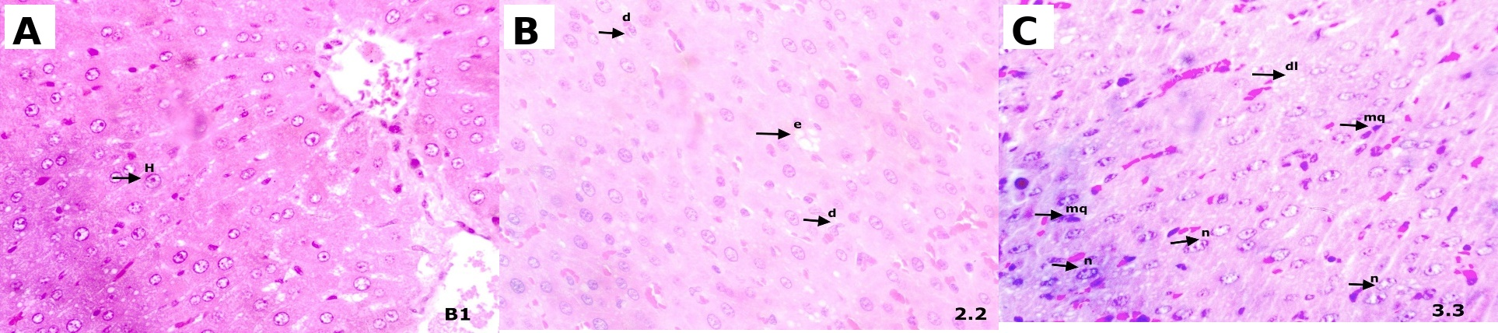
Figure 2. Liver histopathology of female rats after 28 days of treatment. A: normal control; B: EEM 200 mg/kg; C: EEM 400 mg/kg. EEM, ethanolic extract of Morus alba leaves.
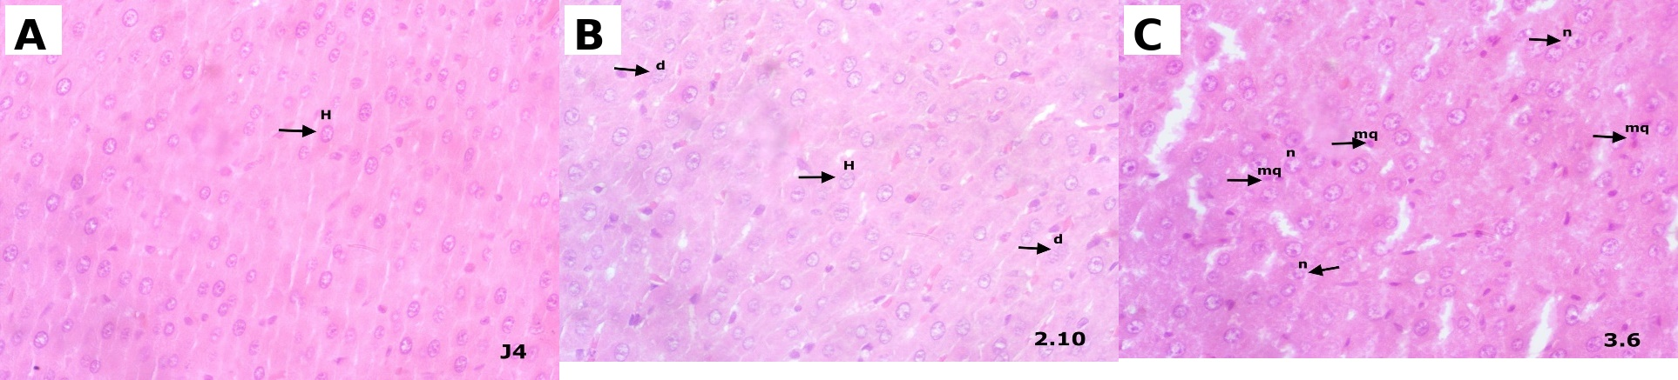
Figure 3. Liver histopathology of male rats after 28 days of treatment. A: normal control; B: EEM 200 mg/kg; C: EEM 400 mg/kg. EEM, ethanolic extract of Morus alba leaves.
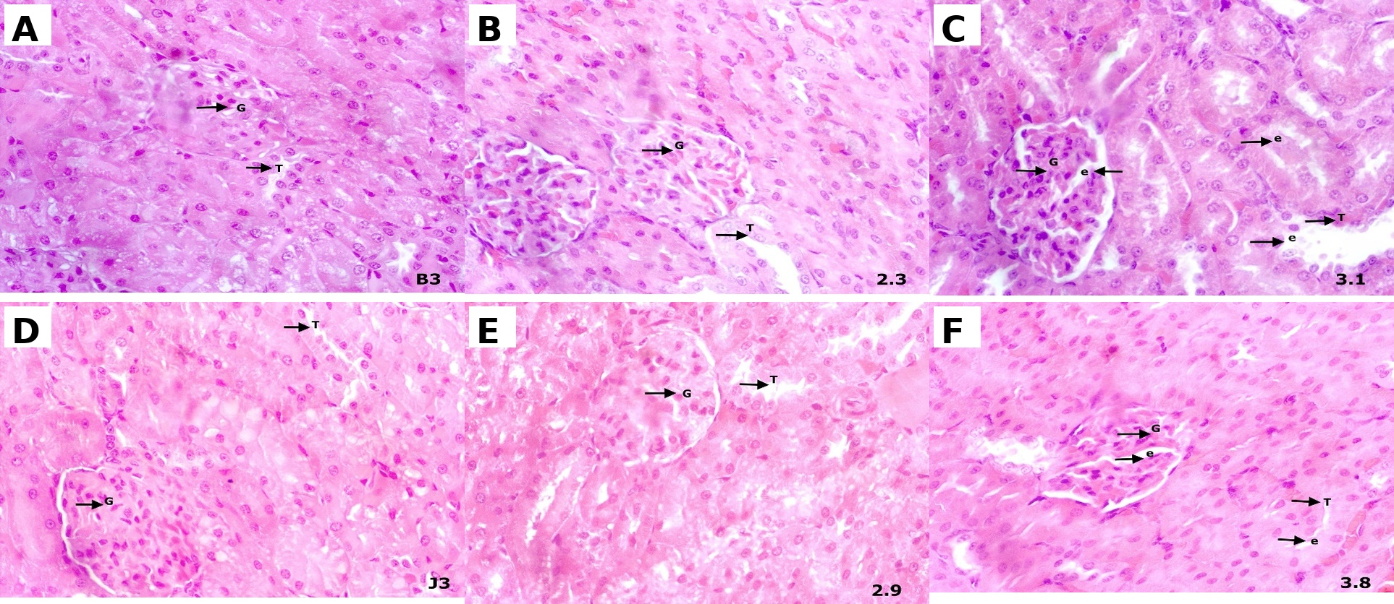
Figure 4. Kidney histopathology of female and male rats after 28 days of treatment. A and D: normal control; B and E: EEM 200 mg/kg; C and F: EEM 400 mg/kg. EEM, ethanolic extract of Morus alba leaves.
DISCUSSION
This study evaluated the 28-day repeated oral toxicity of ethanolic M. alba leaf extract in male and female Wistar rats. No mortality or overt clinical toxicity was observed, and all groups showed progressive body-weight gain. Body weight is a sensitive indicator in repeated-dose toxicity studies because marked weight loss or growth suppression may reflect systemic toxicity, metabolic stress, or reduced food intake¹⁹. Although the magnitude of body-weight gain differed among groups and sexes, the absence of weight loss supports general tolerability of EEM under the conditions assessed.
The findings are broadly consistent with previous safety reports on M. alba preparations. Acute toxicity assessment of M. alba leaf extract reported no major toxic signs after high-dose exposure, and repeated administration of an aqueous extract produced no treatment-related toxicity at higher doses than those assessed here^{11,13}. The present study extends available information by examining an ethanolic leaf extract, for which the phytochemical profile may differ from that of aqueous preparations because solvent affects compound yield and biological activity^{14,15}.
Hematological assessment provides an indication of possible systemic toxicity because blood cells and hematopoietic tissues can be sensitive to toxicant exposure. In male rats, erythrocyte, leukocyte, and platelet parameters were comparable across groups. In female rats, several erythrocyte-related indices differed statistically, but the overall pattern did not indicate overt hematological toxicity. Rat hematological parameters may vary with age, sex, strain, housing conditions, and animal source²⁰. Therefore, isolated statistically significant changes should be interpreted in conjunction with dose-response pattern, related parameters, and histological evidence.
Serum creatinine and urea were measured as kidney-function indicators, while AST and ALT were assessed as markers of hepatocellular injury. Creatinine and urea are commonly used indicators of renal function and nitrogen metabolism, although both can be affected by physiological factors other than renal injury^{21,22}. In this study, urea did not differ significantly between normal control and treated groups, and male creatinine values were comparable across groups. Female creatinine differed in a non-dose-dependent pattern involving the 200 mg/kg group.
AST and ALT did not differ significantly between normal control and EEM-treated groups in either sex. These enzymes are commonly used in liver-function assessment, although AST is less liver-specific than ALT because it is present in several tissues²³. The absence of significant aminotransferase elevations suggests that EEM did not produce detectable biochemical liver injury during the 28-day period. Nevertheless, normal serum enzyme concentrations do not exclude early or mild tissue-level injury.
Histopathology provided the principal safety signal. At 200 mg/kg, liver sections showed mild hydropic or cellular degeneration, whereas kidney tissues remained preserved. At 400 mg/kg, moderate hepatic changes, including fatty degeneration, necrosis, and inflammatory cell infiltration, and mild renal edema were observed. The liver is vulnerable to repeated xenobiotic exposure because it is a principal site of metabolic activation and detoxification²⁴. The renal edema at 400 mg/kg may reflect early renal stress because renal tubular cells are exposed to filtered xenobiotics and metabolites during elimination²⁵.
The interpretation of the findings is limited by the lack of a reported voucher specimen number and quantitative phytochemical standardization, as well as by the absence of reported organ-weight, food-intake, water-intake, and quantitative histopathological-scoring data. Only two dose levels were evaluated. Therefore, the present results should be regarded as preliminary, and a no-observed-adverse-effect level cannot be established from the available data. Future studies should use authenticated and chemically characterized extracts and include organ-weight measurements, quantitative histopathology, and broader dose ranges.
CONCLUSION
Ethanolic Morus alba leaf extract was generally tolerated after 28 days of repeated oral administration in male and female Wistar rats, with no mortality, overt clinical toxicity, or consistent biochemical evidence of liver or kidney dysfunction. However, the liver and kidney histopathological alterations observed at 400 mg/kg body weight indicate potential dose-related target-organ effects. Further studies using authenticated and standardized extract preparations, broader dose ranges, longer exposure periods, organ-weight assessment, and quantitative histopathology are needed before this extract is advanced as a therapeutic candidate for metabolic syndrome.
ACKNOWLEDGEMENTS
Not declared.
CONFLICT OF INTEREST
The authors declare no conflict of interest.
ETHICAL APPROVAL
The animal study protocol was approved by an institutional research ethics committee (Approval No. 12.199/KOMETIK/STIFA/XII/2025).
REFERENCES
- Obeidat AA, Ahmad MN, Ghabashi MA, Alazzeh AY, Habib SM, Abu Al-Haijaa D, et al. Developmental trends of metabolic syndrome in the past two decades: a narrative review. J Clin Med. 2025;14(7). doi:10.3390/jcm14072402.
- Religioni U, Barrios-Rodríguez R, Requena P, Borowska M, Ostrowski J. Enhancing therapy adherence: impact on clinical outcomes, healthcare costs, and patient quality of life. Medicina (Kaunas). 2025;61(1). doi:10.3390/medicina61010153.
- Li M, Ding L, Cao L, Zhang Z, Li X, Li Z, et al. Natural products targeting AMPK signaling pathway therapy, diabetes mellitus and its complications. Front Pharmacol. 2025;16:1534634. doi:10.3389/fphar.2025.1534634.
- Altanam SY, Darwish N, Bakillah A. Exploring the interplay of antioxidants, inflammation, and oxidative stress: mechanisms, therapeutic potential, and clinical implications. Diseases. 2025;13(9). doi:10.3390/diseases13090309.
- Batiha GE, Al-Snafi AE, Thuwaini MM, Teibo JO, Shaheen HM, Akomolafe AP, et al. Morus alba: a comprehensive phytochemical and pharmacological review. Naunyn Schmiedebergs Arch Pharmacol. 2023;396(7):1399-1413. doi:10.1007/s00210-023-02434-4.
- Chen S, Xi M, Gao F, Li M, Dong T, Geng Z, et al. Evaluation of mulberry leaves' hypoglycemic properties and hypoglycemic mechanisms. Front Pharmacol. 2023;14:1045309. doi:10.3389/fphar.2023.1045309.
- Suthamwong P, Minami M, Okada T, Shiwaku N, Uesugi M, Yokode M, et al. Administration of mulberry leaves maintains pancreatic beta-cell mass in obese/type 2 diabetes mellitus mouse model. BMC Complement Med Ther. 2020;20(1):136. doi:10.1186/s12906-020-02933-4.
- Salampe M, Rahimah S, Nur S, Mamada SS, Biring FS, Keyzia K, et al. Uji aktivitas antioksidan ekstrak daun murbei (Morus alba) menggunakan metode BCB, CUPRAC, dan FRAP. Jurnal Mandala Pharmacon Indonesia. 2025;11(1):149-157. doi:10.35311/jmpi.v11i1.723.
- Salampe M, Widiasri DAD, Wahyuddin N, Agus RR, Imrawati I, Awaluddin A, et al. Therapeutic effects of Morus alba leaf extract on fasting blood glucose and pancreatic beta-cell restoration in HFD-STZ-induced diabetic rats. Jurnal Jamu Indonesia. 2026;11(2):111-118. doi:10.29244/jji.v11i2.452.
- Porasar P, Gibo R, Gogoi B, Sharma D, Bharadwaj A, Gam S, et al. A systematic review on the phytochemistry, isolated compounds, nutritional benefits, pharmacology and toxicology of the plant species Morus alba L. Discover Plants. 2025;2(1):7. doi:10.1007/s44372-024-00043-w.
- Fauzi A, Kifli N, Noor MHM, Hamzah H, Azlan A. Hematological, biochemical, and histopathological evaluation of the Morus alba L. leaf extract from Brunei Darussalam: acute toxicity study in ICR mice. Open Vet J. 2024;14(3):750-758. doi:10.5455/OVJ.2024.v14.i3.1.
- Li Y, Zhang X, Liang C, Hu J, Yu Z. Safety evaluation of mulberry leaf extract: acute, subacute toxicity and genotoxicity studies. Regul Toxicol Pharmacol. 2018;95:220-226. doi:10.1016/j.yrtph.2018.03.007.
- Marx TK, Glávits R, Endres JR, Palmer PA, Clewell AE, Murbach TS, et al. A 28-day repeated dose toxicological study of an aqueous extract of Morus alba L. Int J Toxicol. 2016;35(6):683-691. doi:10.1177/1091581816670597.
- Bouasla I, Hamel T, Barour C, Bouasla A, Hachouf M, Bouguerra OM, et al. Evaluation of solvent influence on phytochemical content and antioxidant activities of two Algerian endemic taxa. Eur J Integr Med. 2021;42:101267. doi:10.1016/j.eujim.2020.101267.
- Sun S, Yu Y, Jo Y, Han JH, Xue Y, Cho M, et al. Impact of extraction techniques on phytochemical composition and bioactivity of natural product mixtures. Front Pharmacol. 2025;16:1615338. doi:10.3389/fphar.2025.1615338.
- OECD. Test No. 407: Repeated Dose 28-day Oral Toxicity Study in Rodents. OECD Guidelines for the Testing of Chemicals, Section 4. Paris: OECD Publishing; 2025. doi:10.1787/9789264070684-en.
- Zhang QW, Lin LG, Ye WC. Techniques for extraction and isolation of natural products: a comprehensive review. Chin Med. 2018;13:20. doi:10.1186/s13020-018-0177-x.
- Coşkun N, Sarıtaş S, Jaouhari Y, Bordiga M, Karav S. The impact of freeze drying on bioactivity and physical properties of food products. Applied Sciences. 2024;14(20). doi:10.3390/app14209183.
- Chapman K, Sewell F, Allais L, Delongeas JL, Donald E, Festag M, et al. An evidence-based approach to define the upper limit of body weight loss in short term toxicity studies. Regul Toxicol Pharmacol. 2013;67(1):27-38. doi:10.1016/j.yrtph.2013.04.003.
- Kampfmann I, Bauer N, Johannes S, Moritz A. Differences in hematologic variables in rats of the same strain but different origin. Vet Clin Pathol. 2012;41(2):228-234. doi:10.1111/j.1939-165X.2012.00427.x.
- Gowda S, Desai PB, Kulkarni SS, Hull VV, Math AAK, Vernekar SN. Markers of renal function tests. North Am J Med Sci. 2010;2(4):170-173.
- Inker LA, Titan S. Measurement and estimation of GFR for use in clinical practice: core curriculum 2021. Am J Kidney Dis. 2021;78(5):736-749. doi:10.1053/j.ajkd.2021.04.016.
- Altaihani RA, Fahad B, Alhazmi S, Albagawi MG, Mohamad N, Almuzaini A, et al. Liver function tests: an updated review article for clinical pathologists. J Pharm Bioallied Sci. 2024;23:1681-1691.
- Zhang Y, Qi Y, Huang S, Jiang X, Xiao W, Wang L, et al. Role of ER stress in xenobiotic-induced liver diseases and hepatotoxicity. Oxid Med Cell Longev. 2022;2022:4640161. doi:10.1155/2022/4640161.
- George B, You D, Joy MS, Aleksunes LM. Xenobiotic transporters and kidney injury. Adv Drug Deliv Rev. 2017;116:73-91. doi:10.1016/j.addr.2017.01.005.

